Vietnam 2026 Macro Outlook




Vietnam’s Gold:

A Quantitative Decomposition of the SJC Wedge

Executive Summary  Vietnam’s domestic gold price, most clearly reflected through Saigon Jewellery Company (SJC.HM) bars, has been driven by two observable betas: the international USD gold cycle and the USD/VND exchange rate. These two explain the direction of the move across the long window, accounting for a meaningful share of the baseline appreciation. However, neither explains the feature that repeatedly makes Vietnam’s gold market look anomalous relative to peers: a persistent, regulated domestic wedge that can widen nonlinearly in times of stress.  In a bullion market where supply and arbitrage are structurally controlled, the wedge behaves like a convenience-yield premium on deliverable, verifiable bars, in situations where households' demand for monetary substitutes rises, substitution of gold form degrades (bars/rings), or when intermediaries reprice inventory.  Vietnam’s bullion market was historically shaped by Decree 24–era supply rigidity, with episodic quantity injections via auctions and discrete sales rather than continuous market-making, along with structurally thin two-way liquidity. Hence, demand shocks clear primarily through the domestic gold price rather than through quantity adjustment. In periods of stress, expectations and positioning intensify this dynamic, generating a self-reinforcing “scarcity + expectations” feedback loop.  This report formalises the framework around three observable components: global gold price, USD/VND, and the domestic wedge, and proposes a measurable methodology to quantify each element. With auditable inputs, it enables identification, sheds light on how pricing works among competing transmission mechanisms, treating the wedge as a state variable embedded in market structure rather than as a residual anecdote:  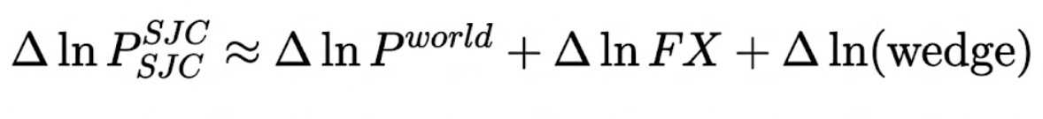  Where: | Overview  Real GDP: US$476.3 billion  Real GDP growth (YoY): 7.09%  GDP per capita: US$4700  Inflation: 3.63%  Unemployment rate: 2.24%  Population: 100.9 million  Sang Le  saigonequitiesforum@gmail.com |  University of Finance - Marketing  Figure 1: SJC Gold Prices  Source: LSEG Workspace  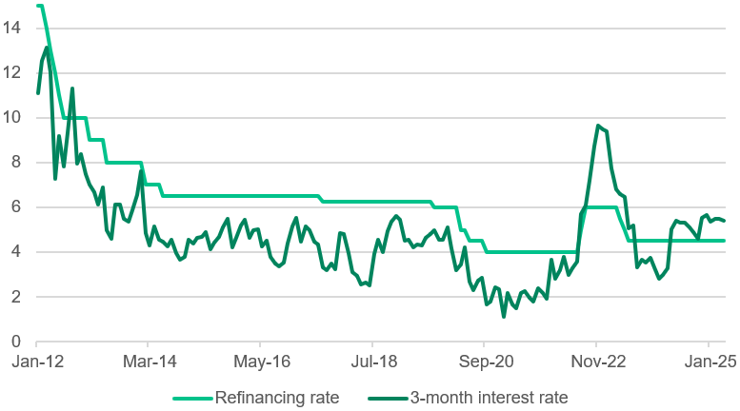  GDP by Sector  Services sector: 42.4%  Industry sector: 37.6%  Agriculture sector: 11.9%  Investment  Total FDI: US$38.2 billion  FDI net inflow: 4.2% of GDP  Total M&A value: US$3.5 billion  Social Indicators  Human Development Index: 0.766  Multidimensional Poverty Index: <1%  Gini coefficient: 0.372

Figure 2: USD/VND  Source: International Monetary Fund (IMF)  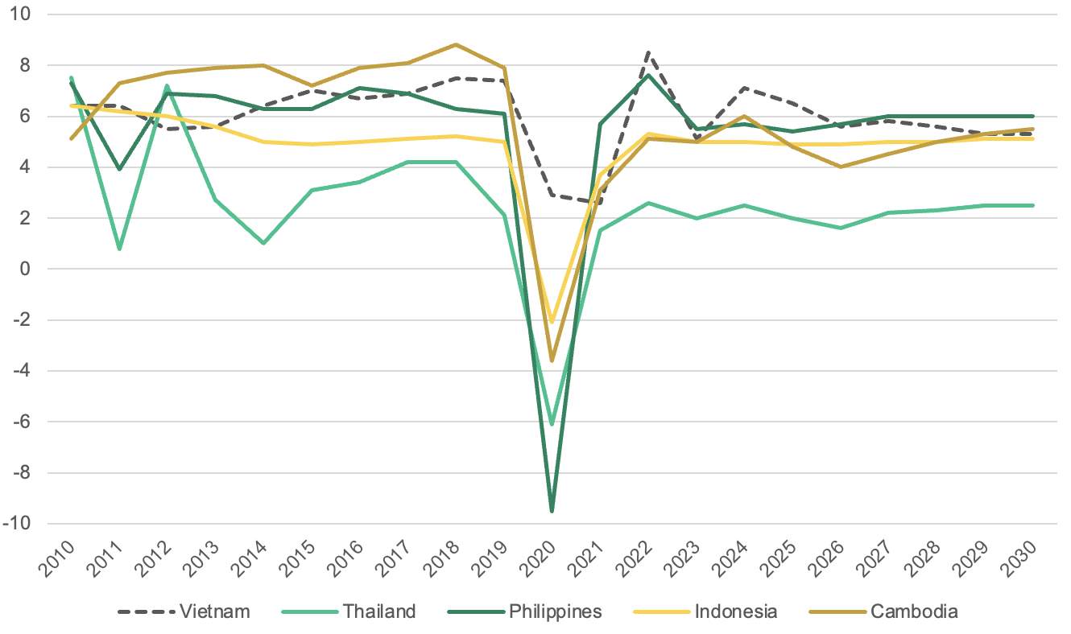  Figure 2: Headline & Core inflation  Source: NSO, OECD  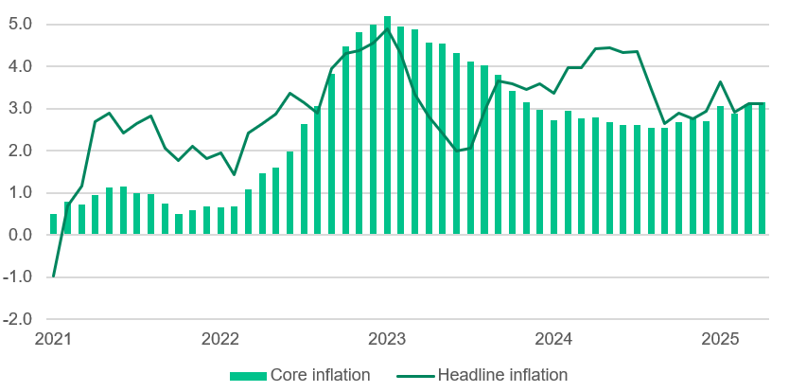  Figure 2: Real wages & Retail sales (YoY %)  Source: OECD  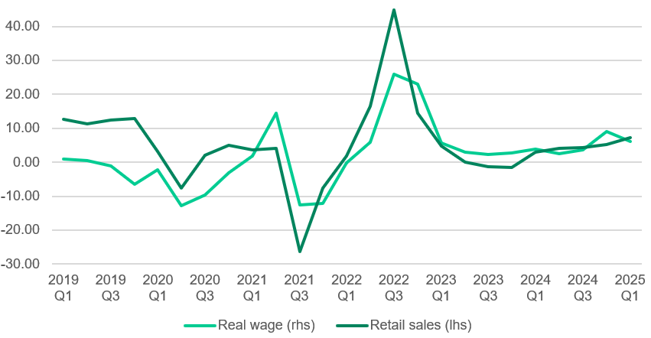  Figure 4: Major public investment projects  Source: International Monetary Fund  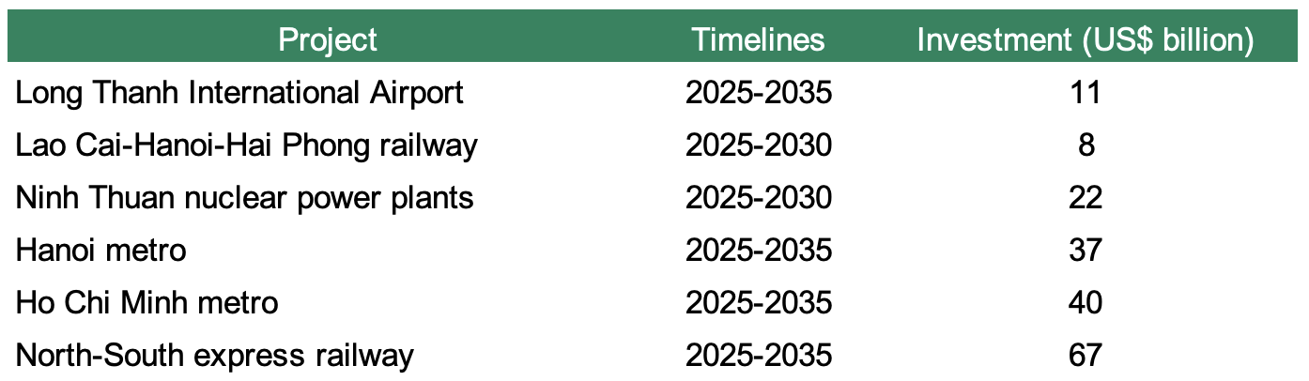 | Why SJC outruns world benchmarks  In a frictionless environment, a globally priced commodity like gold should obey a loose parity condition once you translate units and currency. Costs are based on freight, insurance, financing, fabrication, taxes, and dealer margins. These are line items that make for a small and relatively stable spread around parity. Any large deviation should naturally self-correct: if domestic prices run rich, metal flows in; if they run cheap, metal flows out. The premium should be mean-reverting, not a state variable.  Yet, SJC prices repeatedly trade above import parity by an amount that is economically and persistently large enough that the State Bank of Vietnam (SBV) treats the gap as a macro-relevant issue. Indeed, the market is clearing under a constraint set different from theory: the arbitrage loop is impaired, and the deviation from parity is not an error term but a part of the equilibrium. There are two main reasons as to why:  First, the premium is not purely cyclical, since the gap can widen and remain elevated even when global gold is not in a vertical run. If the only driver were global betas plus FX translation, deviations from the parity should compress as soon as global impulse fades away. Yet, the domestic edge can sit at a high level for extended periods of time, and then reaccelerate during stress.  The persistence is because the domestic supply is not elastically responsive. When people suddenly want more SJC bars, there is not an automatic flow of new supply to push prices back. At the same time, buyers start valuing the immediacy of having gold right now, verified quality, and resale liquidity, hence the price of these three gets internalised into the gold market price itself.  Second, the premium is product-segmented. The SJC bullion exhibits different behaviour compared to rings or other jewellery products, highlighting segmentation between bar and non-bar products. The segmentation is attributable to differences in deliverability, standardisation, liquidity hierarchy, and the regulatory perimeter. In other words, the wedge is not a generic cultural preference but a microstructure and policy outcome that attaches disproportionately to the instrument that functions closest to a monetary asset domestically.  Altogether, they motivate a decomposition: Vietnam’s observed price is best understood as import-parity fundamentals (global gold × FX × conversion) plus a domestic wedge that is itself measurable and economically interpretable.  A cleaner way to frame the move is through the accounting identity:  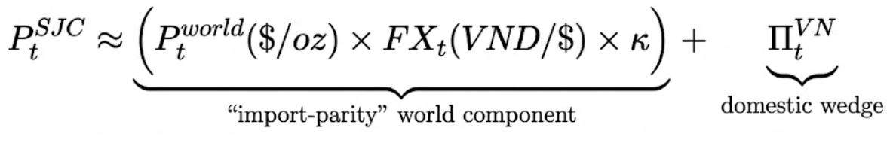  Where:  - κ is the unit conversion from troy ounce to tael. Vietnam’s tael is 37.5g; a troy ounce is 31.1035g. Therefore, κ ≈ 37.5 / 31.1035 ≈ 1.2057  - π(t)_VN corresponds to what the decomposition visual calls the combined “USD/VND gap” and “gold gap” — i.e., the full deviation of domestic SJC from import-parity mechanics:

Figure 2: USD/VND  Source: LSEG Workspace  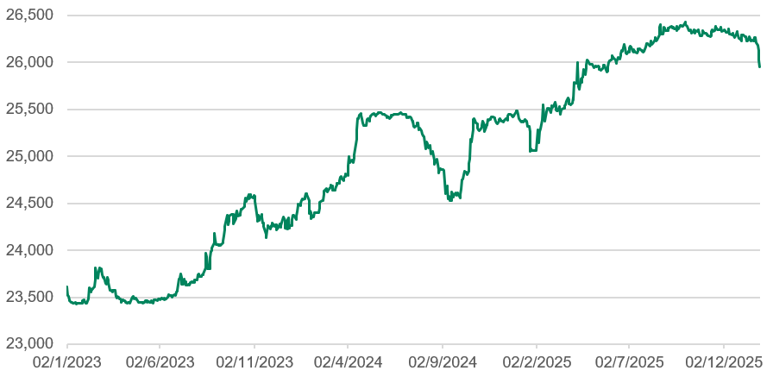  Figure 2: CNY/VND, JPY/VND  Source: LSEG Workspace  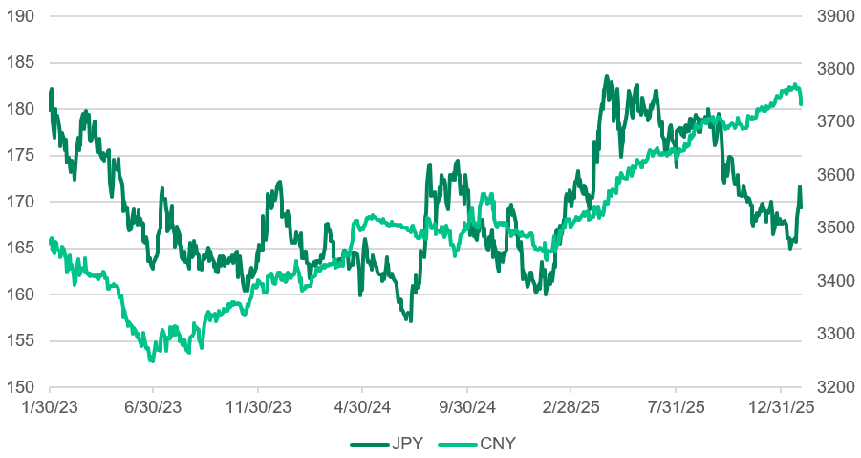Figure 3: Deposit rates (%)  Source: LSEG Workspace  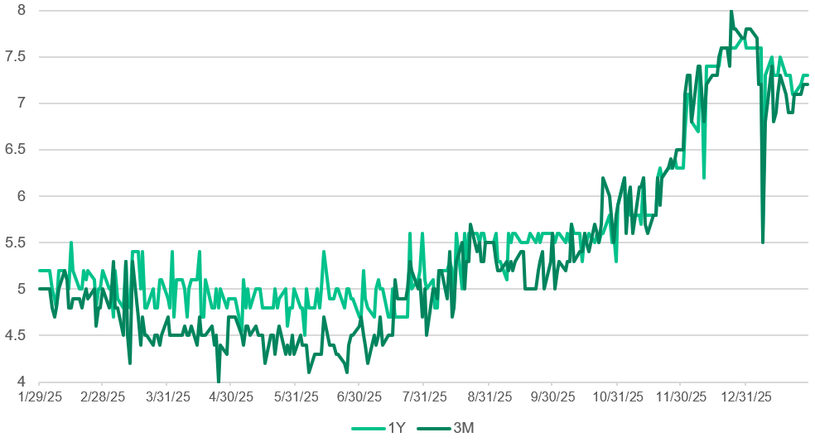  Figure 4: Target vs actual credit growth (%)  Source: International Monetary Fund  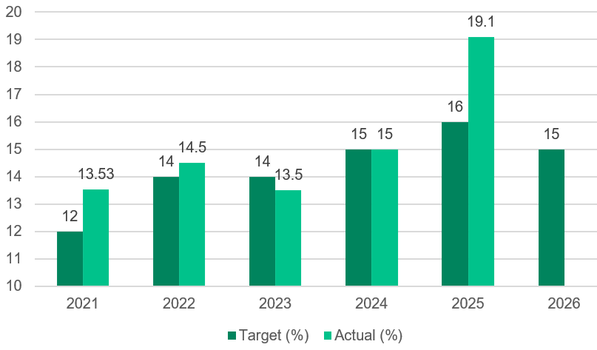  Figure 2: Interbank rates (%)  Source: LSEG Workspace  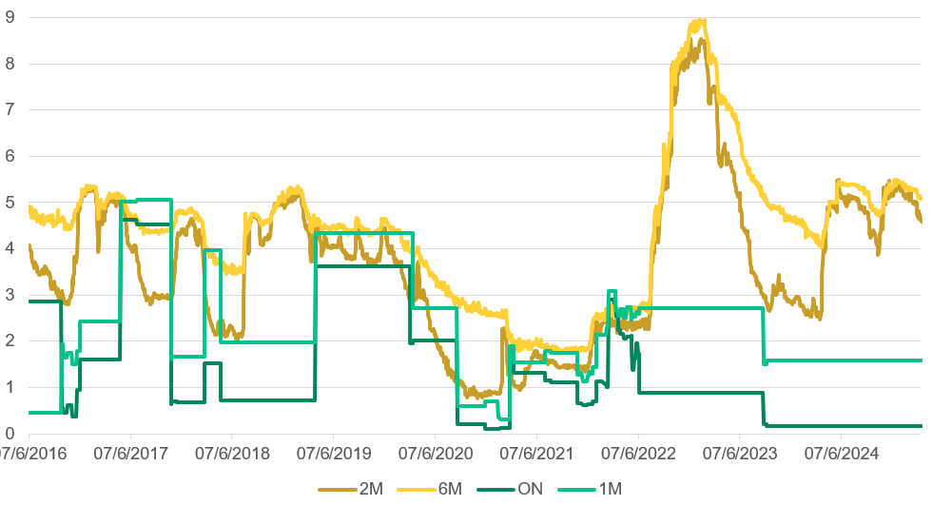  Figure 4: Credit growth vs GDP growth (YoY %)  Source: LSEG Workspace  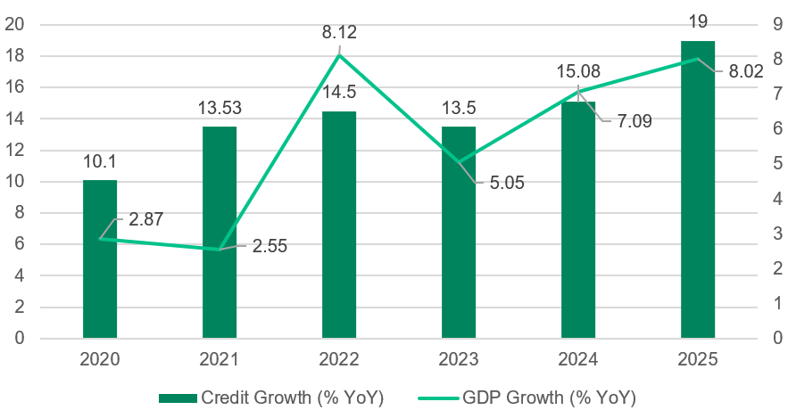  Figure 1: VN Index, gold spot price (US$)  Source: LSEG Workspace  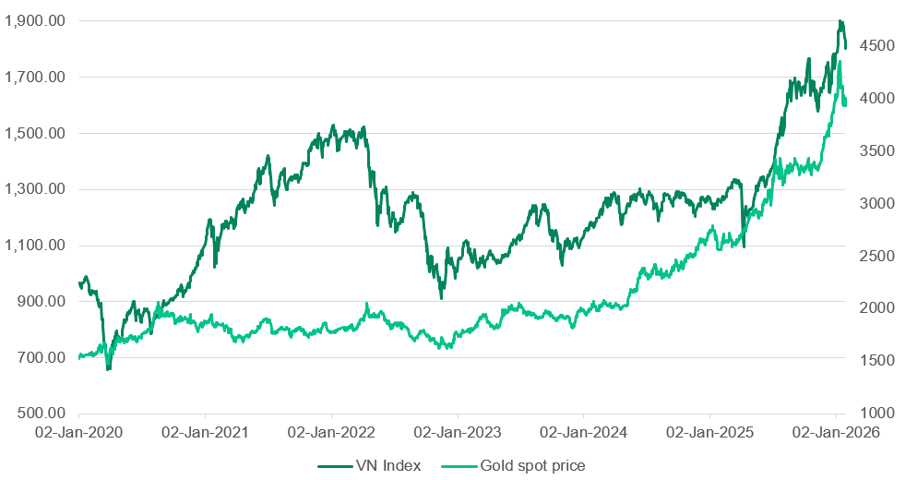  Figure 1: Total reserve, ASEAN  Source: OECD  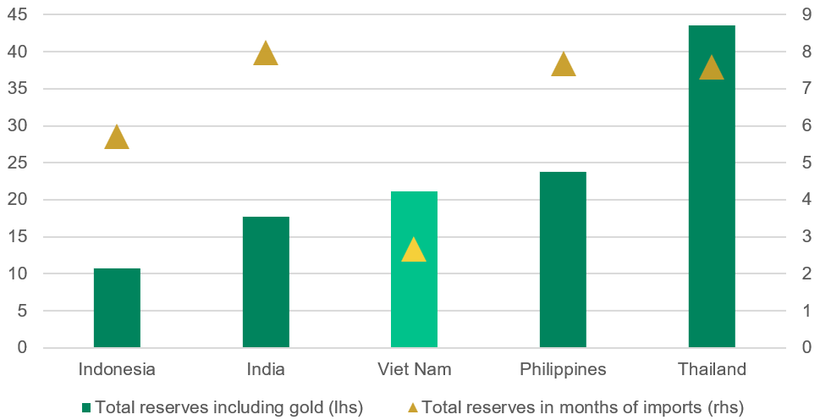  Figure 2: USD/VND FX forward swap  Source: International Monetary Fund (IMF)  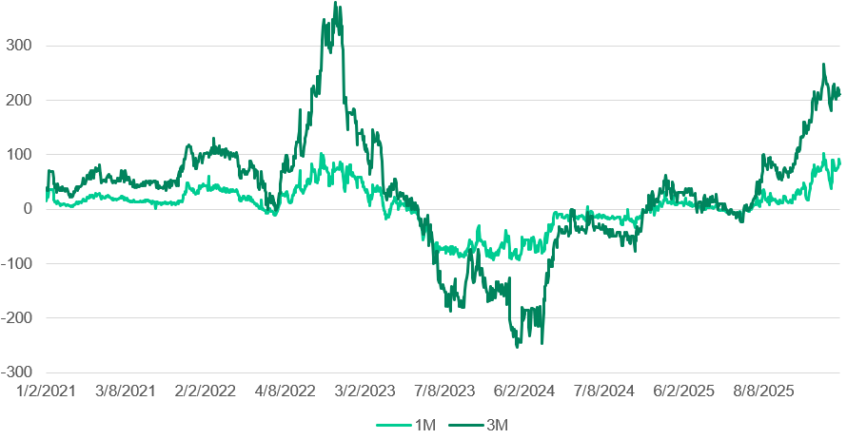  Figure 2: Vietnam OMO framework, market liquidity  Source: LSEG Workspace  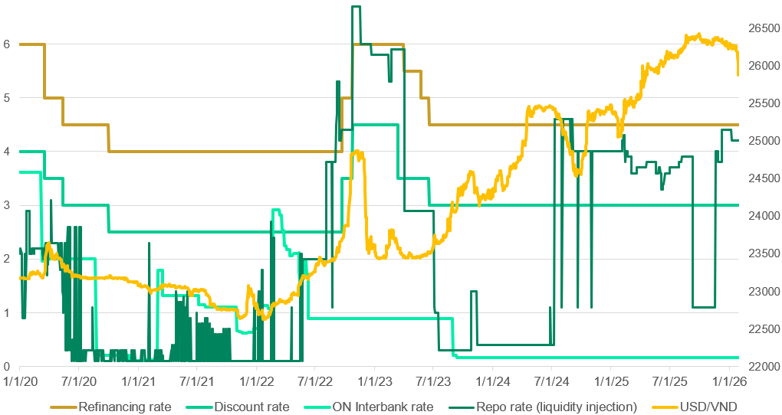  Figure 2: Figure 2: Benchmark yield convergence (%)  Source: LSEG Workspace  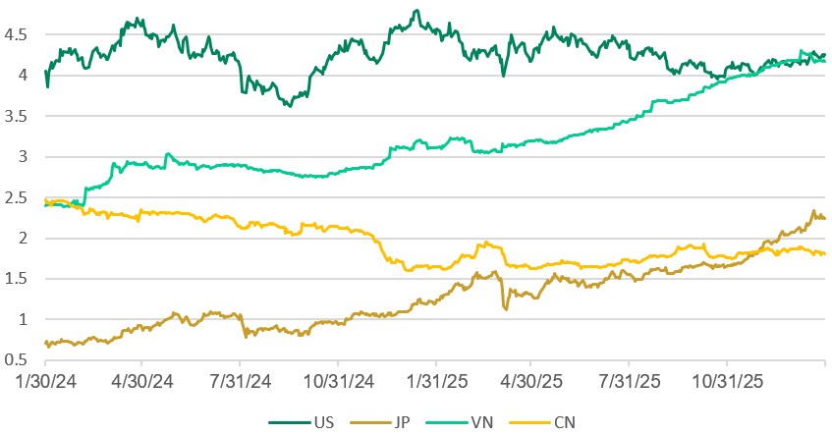  Figure 2: Total reserve in months of imports  Source: LSEG Workspace  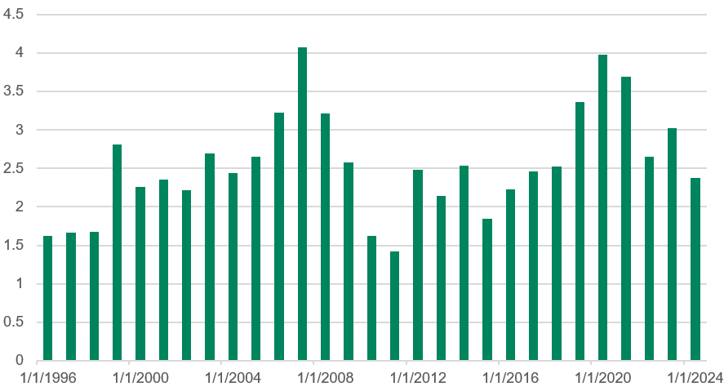 | Studying historical prices  - 1 SJC bar price discrepancies with FX  From 2019 to 2024, the price points to a strong but “explainable” bull market. It was broadly consistent with the global gold cycle translated into VND, coupled with a pandemic-era safety bid, inflation/real-rate cycle, and renewed risk premia later on. Domestic frictions do exist, but they do not dominate the slope.  From 2025 to early 2026, an outlier occurs in the 82% midpoint growth, unexplainable by geopolitics alone. Rather, the regulatory environment shifted: as the wedge expanded sharply, domestic demand became more inelastic under constraint, or both. Under impaired arbitrage, those forces show up as a level re-pricing, not incremental drift. FX mechanically amplified this trend, and because gold is priced in USD, VND returns mechanically embed an extra FX cost, even in a fully arbitraged market; when the Dong weakens, gold prices rise faster as it is priced in US dollars. When the currency is stable, gold returns are more muted. This effect is strongest during periods of stress, when emerging-market currency risk increases and households buy gold as protection against exchange rate risk.  However, the exchange rate only explains the overall direction and part of the size of the move. It does not explain why SJC gold bars trade at a large and persistent premium compared to import parity. That persistent gap is the “wedge,” and in the 2025 to early 2026 period, this wedge becomes the main driver of price moves rather than global gold or FX alone.  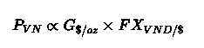  A disciplined framework and a concrete decomposition  - Price-level decomposition (import parity with a wedge)  Here, we define SJC as an import-parity anchor plus a domestic premium:  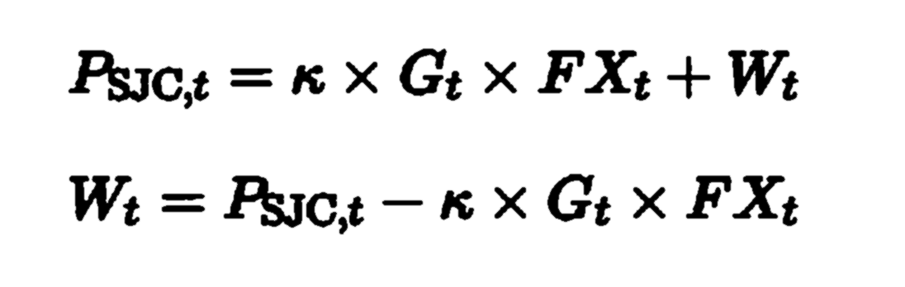  Wₜ​ aggregates the non-arbitraged components of the SJC price: taxes/fees, fabrication and distribution premia, inventory and balance-sheet risk carried by intermediaries, scarcity rents, and policy/microstructure premia when supply is administratively inelastic.  - Return attribution  By changing the original equation into log form:  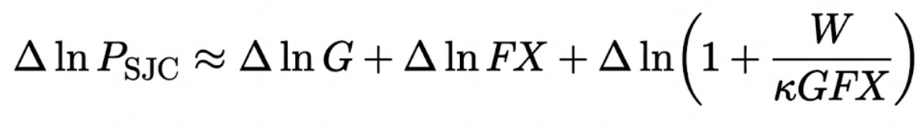  We isolate the wedge as a measurable residual in the same units as returns, which can prove useful as the wedge is state-contingent and can accelerate when constraints bind. As an example, on 26 January 2026, G ≈ 5,000G USD/oz; FX ≈ 26,142 VND/USD; Κ ≈ 1.2057; Domestic SJC sell ≈ 177.0 million VND/tael. Therefore, P_parity ≈ 5,000 × 26,142 × 1.2057 ≈ 157.6 million VND/tael. The wedge then is: Π ≈ 177.0 − 157.6 = 19.4 million VND/tael, which represents roughly 11–16% of the domestic price at the time (Figure 13). From this example, we can spot several implications. First, in a world where global gold sits at new highs, Vietnam pays an extra ~VND19mil per tael at SJC. Second, the wedge of ~VND19mil/tael is large enough to materially change household realised returns and portfolio choice, presenting itself as a macro-financial transmission channel.  Structural and cyclical channels that make Wₜ  - Policy-induced supply constraints: Decree 24 and the legacy of the bullion regulation  For most of the past decade, the bullion market has been organised around administrative control, over who can produce bars and how raw gold can enter the bar-production chain. Decree 24 concentrated gold bar production and the import/export function for bar inputs under government control.  As supply is institutionally inelastic, domestic pricing stops behaving like a simple FX-translated global benchmark. The short-run supply curve for SJC bars becomes steep - sometimes effectively vertical, so demand shocks do not clear through quantity. They clear through price premia, i.e., Wₜ. That is the structural anchor of the wedge: in a constrained system, the wedge is the clearing mechanism.  The 2024 episode makes this concrete, when the SBV restarted gold bar auctions after roughly an eleven-year hiatus to stabilise the domestic market. The signal embedded in that decision is straightforward: left to itself, the market was not generating an elastic supply response at the prices being printed, and the wedge had become macro-relevant. Auction outcomes also highlighted a second-order constraint: when participation is selective, and the market lacks deep two-way liquidity, official quantity injections do not automatically translate into continuous market-making. Intermediaries facing policy, inventory, and compliance risk rationalise balance sheets and widen spreads, altogether conditions under which Wₜ can remain elevated even when the policy intent is to compress it.  So the mechanism is not uniquely Vietnamese in the concept that many economies have restricted bullion markets, but Vietnam’s specific combination of objectives (de-goldization and FX management) and market structure makes the wedge durable in calm and explosive in stress.  - Decree 232/2025 and the “regime-change premium”  Decree 232/2025 is a meaningful structural break: it moves the regulations away from the Decree 24-era monopoly architecture and signals an intent to broaden the production and supply perimeter over time. But market prices do not respond to the direction of reform alone, they respond to the implementation path, the timing of supply elasticity, and the distribution of regulatory risk across intermediaries. That is why wedges can widen.  Firstly, implementation uncertainty is a wedge creator. In transition windows, the market is forced to price unknowns: who is licensed, what standards apply, how quickly capacity can be certified, whether raw input channels actually open, and whether enforcement tightens before supply becomes elastic. When the supply response is delayed, the marginal unit of bullion remains scarce in the near term so that Wₜ can rise as the long-run regime coordinated enforcement. Secondly, bullion carries an option on policy when rules are moving. If agents believe the state may tighten inspections, restrict flows, or slow approvals during transition, holding physical bullion becomes an insurance asset with embedded convexity: downside is limited to a future wedge compression if supply expands quickly; upside persists if supply remains constrained. That asymmetry shows up as a higher convenience-yield-like premium - again, Wₜ.  Finally, intermediary balance sheets price compliance risk. Dealers and market makers do not set spreads only off volatility. In a shifting regulatory environment, inventory becomes riskier to warehouse: documentation, auditability, and potential scrutiny raise the expected cost of carrying stock. The rational response is wider bid–ask spreads and more conservative quoting, which mechanically supports a higher wedge.  Hence, a fiscal change can still generate a short-run regime-change premium embedded in Wₜ. The wedge narrows when, and only when, the change translates into credible, scalable supply elasticity and reliable market-making capacity, not when the decree is announced.  - Official intervention is not the same as market-making liquidity  When the SBV intervenes to “close the gap” via auctions, administrative supply measures, or domestic-international divergence, it differs from how a central bank does not spend institutional capital on a pricing gap unless the wedge is real, policy-conditioned, and macro-relevant.  But quantity intervention is not the same thing as continuous liquidity provision. Auctions and episodic sales can narrow WtWₜWt​ by adding metal at the margin, yet they do not automatically repair the market’s microstructure. Two frictions persist:  First, intervention is a signal, not just a flow. Large, visible actions tell the market that conditions are abnormal. In a segmented retail market, that can concentrate attention, pull forward demand, and sharpen one-way positioning — especially if participants believe supply injections will be sporadic rather than a standing facility. In that setting, the flow effect (more supply) competes with the signal effect (higher salience of scarcity).  Second, enforcement is not liquidity. The 2024 phase of heightened inspections and scrutiny which reported alongside concerns about manipulation can tighten compliance constraints precisely when the market most needs intermediaries to warehouse risk. In thin markets, dealers respond by rationing inventory, widening quotes, and reducing two-way depth. “Informal liquidity” steps back, formal liquidity is not yet deep, and the wedge becomes more resilient.  So the wedge can survive, or even re-widen, under intervention when the policy response is episodic and the market’s capacity to intermediate risk is constrained. The takeaway is structural: closing Wₜ​ requires not only supply injections, but also durable market-making conditions that keep two-way liquidity functioning under scrutiny and stress.  - “Goldization”, expectations, and the hoarding feedback loop  Vietnam’s gold demand cannot be read as ordinary commodity consumption. For a large share of households, physical gold, especially SJC bars, functions as a monetary asset: a portable, settlement-ready store of value that sits outside the banking system. That is precisely why policymakers frame “goldization” as a macro-financial issue rather than a lifestyle preference: it is a portfolio-allocation problem with implications for liquidity, confidence, and the transmission of policy. Two structural features make this demand wedge-forming: One, substitution across gold forms is imperfect, especially under stress. Rings/jewelry may carry similar metal content, but they are not equivalent on the attributes that matter in a panic: resale certainty, authenticity verification, bid–ask discipline, and network liquidity. Distribution and verification frictions create a liquidity hierarchy across products, with SJC often at the top. In effect, SJC behaves like “brand money”: part metal, part liquidity claim. That liquidity claim is priced as a premium, ultimately one component of Wₜ. Second, expectations convert scarcity into convexity.  When participants believe imports will remain tight, interventions will be delayed or episodic, and demand will persist, holding SJC resembles holding an asset with a convenience yield plus an embedded policy option: if supply is credibly liberalized, the premium compresses; if not, the premium persists or expands. This asymmetry produces observable behaviors like nonlinearity, where the premium is modest in calm periods but becomes convex when stress rises. An inventory hoarding situation also occurs, where selling dries up in rallies because the opportunity cost of parting with “liquidity-grade” bullion increases. Self-reinforcing squeezes also happen, where higher prices strengthen the expectation of higher prices, which reduces supply, which lifts prices again.  The macro trigger is not price; it is trust and constraint. When households perceive property as illiquid or policy-exposed, when corporate credit channels look impaired, or when risk assets feel fragile, gold becomes the default refuge. In those windows, demand becomes less elastic to price and more elastic to fear, credibility, and institutional confidence.  This matters because gold markets are reflexive: demand is shaped by expectations of financial repression, tail-risk hedging needs, and confidence in domestic financial claims. And the loop becomes materially stronger under Channel A. In a free-import environment, hoarding pressure invites arbitrage and inflows. In a constrained environment, it cannot be met with quantity so it clears through Wₜ.  - FX pass-through: USD/VND is not “just conversion,” it is part of the macro hedge  Figure 15 isolates the FX term for a reason: in Vietnam, USD/VND is not a background variable, it is part of the asset’s economic function. Gold is priced in USD globally, so the mechanical mapping is trivial: holding gold in VND embeds a USD exposure through the parity equation. But in Vietnam, gold also carries a hedge utility that is explicitly linked to FX expectations and liquidity conditions, which is where FX begins to interact with the wedge.  USD/VND therefore enters through two distinct channels:  Mechanical translation (parity channel): Even under full arbitrage, VND gold returns inherit USD gold returns plus the change in USD/VND. This is the clean “accounting” effect.  Macro-hedge channel (risk premium channel): Gold demand in Vietnam is sensitive not only to spot USD/VND, but to the distribution of future FX outcomes: forward expectations, episodes of USD funding tightness, and perceived tail risks. When the market prices a higher probability of FX stress, even without immediate spot depreciation, the hedge value of physical gold rises. That lifts the convenience-yield component of holding SJC and can translate into a higher WtWₜWt​ when physical supply is inelastic.  In other words, FX matters twice: first as a conversion factor, and second as a state variable for domestic risk appetite. When that state variable deteriorates, households shift from “metal exposure” to “hedge demand,” selling thins, physical availability tightens, and the wedge can become self-reinforcing rather than mean-reverting.  - Market microstructure: bid-ask spreads, inventory risk, and segmentation  Even if policy were neutral, retail bullion pricing is never frictionless. What turns Vietnam’s premium into a persistent wedge is that the market clears through a thin, segmented microstructure where intermediaries must price balance-sheet and compliance risk in real time. Here, three microstructure elements matter:  Bid–ask spreads as a liquidity tax:  Retail bullion trades with materially wider two-way spreads than exchange-traded assets. When volatility rises or inventories become harder to source, dealers protect themselves by widening quotes. That spread is not just “transaction cost”, it is a direct measure of how costly it is to intermediate risk and how shallow the market is at the margin.  Inventory and volatility risk premia:  Dealers warehousing physical bars face funding costs, price-gap risk, and mark-to-market uncertainty, but in Vietnam they also face policy and auditability risk. When those risks rise,rational response is to reduce inventory, ration supply, and require higher compensation for immediacy — mechanically supporting a higher Wₜ​.  Segmentation and “brand premium”:  SJC is not merely gold; it is the focal standard for resale liquidity and verification. That standardization creates network effects that liquidity clusters in the product perceive as most acceptable. In stress, that clustering intensifies, which raises the premium on SJC relative to other forms even when the underlying metal is similar.  Reports of “cash-only” or informal trading dynamics are consistent with this structure: when compliance constraints tighten, informal liquidity retreats; when informal liquidity retreats, spreads widen; when spreads widen, arbitrage weakens further. The result is not a mysterious mispricing. It is the predictable outcome of a globally priced asset trading through a domestically constrained, compliance-sensitive, thin-liquidity market where the wedge is the price of immediacy and certainty under constraint.

Figure 3: Capital adequacy ratios (%)  Source: CEIC  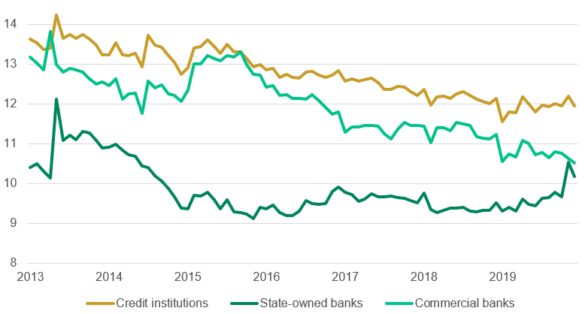  Figure 3: Outstanding private debt (VND trillion)  Source: AMRO, OECD  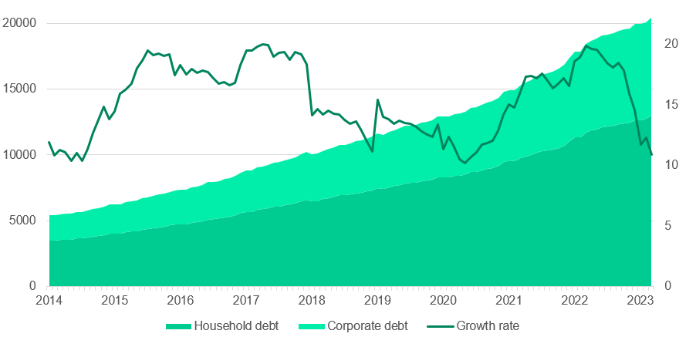  Figure 59: NPLs ratio  Source: CEIC  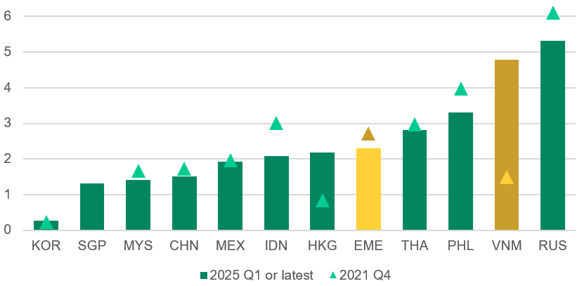  Figure 3: Shares of corporate sector debt (%)  Source: AMRO, OECD  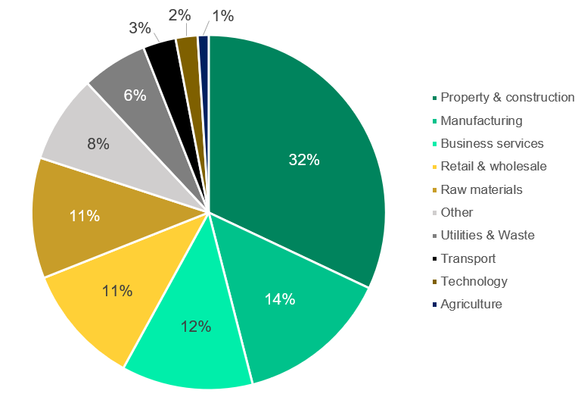 | - The missing piece: the wedge behaves like a scarcity premium + option on policy  The part that’s routinely under-explained is why the domestic premium is not arbitraged away and why it sometimes balloons.  Vietnam is structurally different. The wedge is not an accident, it is the predictable outcome of institutional design. The gold bar market is regulated and supply is not allowed to respond elastically to price. For years, the policy objective has been macro-financial (contain “goldization,” protect FX stability), and the instrument set has been administrative: restrictions on who can produce bullion, how distribution is organized, and how raw gold imports are managed. The result is that arbitrage is not merely “costly”, it is state-contingent. Supply becomes policy-elastic rather than price-elastic.  Once quantity is constrained, the market clears through price. When demand accelerates whether driven by hedging motives, confidence shocks, or portfolio substitution then physical supply cannot scale smoothly, so the adjustment loads onto the premium. In that environment, the wedge is not a nuisance term to be netted out; it is the equilibrium variable that equilibrates a capped quantity with a shifting demand curve. That is also wedge’s labels as “fees/taxes/margins” can also be seen as:  Scarcity rent: the price of immediate deliverable bullion under constrained supply.  Risk premium: compensation for inventory, volatility, and compliance/policy risk borne by intermediaries.  Expectation component: the market’s pricing of future policy stance, the credibility and timing of supply actions, and the perceived probability of macro/FX stress.  Together, these components explain why the wedge can persist in calm periods and become convex in stress, exactly the pattern the decomposition is designed to quantify.  A long window  - What can be attributed to global factors?  A non-trivial portion of Vietnam’s SJC uptrend over 2019–2024 is simply global gold translated into VND and it should be treated as such before invoking any domestic anomaly.  2020: the global safe-asset repricing. The ~+31.7% midpoint jump from end-2019 to end-2020 is consistent with the pandemic shock: collapsing real yields, extreme uncertainty, and a broad flight into liquid hedges. In that environment, gold’s USD beta dominates, and Vietnam’s SJC largely rides the same impulse.  2021–2024: a slower, policy-driven global cycle. The subsequent +8–12% annual ranges fit the sequence the world actually lived through: reopening and reflation, then an inflation shock, then rate hikes and tighter financial conditions, followed by renewed geopolitical and tail-risk premia. Gold did not move in a straight line, but the net drift remained positive as real-rate expectations, risk appetite, and hedging demand rotated across environments.  Global gold and macro uncertainty provide the base force, and USD/VND translation modulates the local slope. The wedge story becomes essential later precisely because this earlier period establishes what “normal global pass-through” looks like.  This is the intuition the decomposition makes explicit: Vietnam earns (or pays) return layers that a world investor in USD gold does not: FX translation plus a domestic wedge. But those layers are not “free alpha.” They are compensation for a policy-conditioned scarcity and liquidity structure, and they carry asymmetric policy risk: if the supply environment loosens or market-making depth improves, the premium can compress quickly even if global gold remains high.  - Where the “global-only” story breaks  The 2025-early 2026 surge is too large and too discontinuous to be carried by a one-factor “global gold” narrative. Even granting an unusually strong year for USD gold, Vietnam’s magnitude implies an additional domestic variable repriced sharply. Vietnam is structurally capable of overshooting global fundamentals for three reasons:  Supply does not clear elastically: When physical bullion availability is administratively inelastic, quantity cannot rise smoothly in response to price signals. The market clears through the premium.  Arbitrage levels are intentionally set: Import-parity deviations are not automatically closed via metal flows; the arbitrage loop is state-contingent, costly, and often effectively capped so the wedge can persist and widen.  SJC functions as a quasi-monetary asset: In stress, SJC is priced not just as metal content but as deliverable liquidity with verification and resale certainty. That changes demand elasticity: buyers are less price-sensitive, sellers become reluctant, and the premium becomes convex.

a

Disclosure
This report has been prepared by Saigon Equities Forum, a student collective solely for educational and informational purposes and intended for general circulation. The views expressed reflect the authors’ independent academic analysis and should not be regarded as genuine investment advice. The report does not necessarily reflect the opinions of Saigon Equities Forum as an organization.

The report does not follow specific investment goals, financial situation, or particular needs of anyone who may receive or read it. This report does not constitute an offer, nor a solicitation for one, to buy or sell any securities or option, futures, or other derivative instruments in any jurisdiction. This report does not constitute an advertisement for any financial instruments. Investors are warned to make independent decisions with regards to their financial situation or investment goals.

The information within was obtained through online sources believed to be reliable, and since it is not independently verified, SEF does not guarantee accuracy or completeness. Opinions, estimates, and projections shown in the report represent the views of the authors at date of publication and are subject to change without prior notice. Saigon Equities Forum carries no obligation to update, amend, or in any way modify this report or inform readers in the event that any subject matter, opinion, projection, or estimate changes or becomes inaccurate. Past performance is not an indication of future performance.

Readers should not make use of this report to violate any laws or regulations or subject Saigon Equities Forum and any of its affiliates to registration or licensing requirements in any jurisdictions that readers are in and make use hereof. Saigon Equities Forum and its affiliates do not accept any liability and loss arising from misuse of this report.

About Saigon Equities Forum
Founded in August 2025, Saigon Equities Forum is a non-profit, student-led initiative, dedicated to bridging knowledge gaps on the Vietnamese equities market and its role within the global financial system. Based out of Ho Chi Minh City, SEF consists of student researchers affiliated with renowned institutions across the world, united under one common purpose to study, analyze, and promote the Vietnamese financial and geopolitical landscape.

Our Team
Equity Research Director  Hung Tran  University of Amsterdam |  | Macro Research Director  Nam Nguyen  New York University |  | Senior Analyst  Tan Ngo  Marquette University
Analyst  Minh Tue Hoang  University of Melbourne |  | Analyst  Jay Chang  University of California, Berkeley |  | Analyst  Khai Son Vo  New York University
Analyst  Duy Nguyen  University of North Carolina, Chapel Hill |  | Analyst  Huy Ta  VinUniversity |  | Analyst  Sang Le  University of Finance - Marketing

© 2025 Saigon Equities Forum. All rights reserved. This report is produced for educational and research purposes. No part of this publication may be reproduced, or distributed in any form without permission.

Reference List
Baochinhphu.Vn. (2024, April 22). Hủy đấu thầu, tiếp tục đấu thầu vào ngày 23/4. baochinhphu.vn. https://baochinhphu.vn/huy-dau-thau-vang-tiep-tuc-dau-thau-vao-ngay-23-4-102240422102411069.htm

- Baochinhphu.Vn. (2024b, May 17). Liên bộ thanh tra hoạt động kinh doanh vàng. baochinhphu.vn. https://baochinhphu.vn/lien-bo-thanh-tra-hoat-dong-kinh-doanh-vang-102240517193130845.htm

- Baochinhphu.Vn. (2025, October 3). Nghị định 232 mở lối cho thị trường: Doanh nghiệp và ngân hàng sẵn sàng 'tăng cung' vàng. baochinhphu.vn. https://baochinhphu.vn/nghi-dinh-232-mo-loi-cho-thi-truong-doanh-nghiep-va-ngan-hang-san-sang-tang-cung-vang-102250909195448503.htm

- VnExpress. (2025, December 11). Quốc hội yêu cầu sớm lập sàn giao dịch vàng. vnexpress.net. https://vnexpress.net/quoc-hoi-yeu-cau-som-lap-san-giao-dich-vang-4992543.html

- Xaydungchinhsach.Chinhphu.Vn. (2025, October 10). TOÀN VĂN: Nghị định số 232/2025/NĐ-CP sửa đổi, bổ sung Nghị định 24/2012 về quản lý hoạt động kinh doanh vàng. xaydungchinhsach.chinhphu.vn. https://xaydungchinhsach.chinhphu.vn/toan-van-nghi-dinh-so-232-2025-nd-cp-sua-doi-bo-sung-nghi-dinh-24-2012-nd-cp-ve-quan-ly-hoat-dong-kinh-doanh-vang-119250829100240562.htm

- Strategic considerations in reserves management. 2025. World Gold Council. https://www.gold.org/goldhub/research/central-bank-gold-reserves-survey-2025/strategic-considerations-in-reserves-management

- Tâm M. (2026, January 25). Ngân hàng Nhà nước lý giải nguyên nhân giá vàng tăng mạnh. Tạp Chí Kinh Tế Sài Gòn. https://thesaigontimes.vn/ngan-hang-nha-nuoc-ly-giai-nguyen-nhan-gia-vang-tang-manh/

- Korean gold prices trade at 20% premium over international gold prices. (n.d.). Voronoi. https://www.voronoiapp.com/economy/Korean-Gold-Prices-Trade-at-20-Premium-Over-International-Gold-Prices-4185

- Reuters.com. (n.d.). reuters.com. https://www.reuters.com/world/china/asia-gold-india-gold-premiums-decadal-high-china-demand-undeterred-by-price-rise-2026-01-30/

- Bloomberg. (n.d.). Bloomberg https://www.bloomberg.com/news/articles/2025-11-07/as-gold-prices-soar-vietnam-wants-hoarded-gold-back-in-circulation

- Gold Price in Vietnamese Dong (Monthly) - Historical Data &. . .. (2025, November 5). YCharts. https://ycharts.com/indicators/gold_price_in_vietnamese_dong_monthly

- Gold price in 10 years. (n.d.). Kaggle: Your Machine Learning and Data Science Community. https://www.kaggle.com/datasets/hoangziet/gold-price-in-10-years

- Tcct. (2025, March 25). Using VAR model to determine the impact of macro factors on gold price in Vietnam. Tạp Chí Công Thương. https://tapchicongthuong.vn/using-var-model-to-determine-the-impact-of-macro-factors-on-gold-price-in-vietnam-138588.htm

- Mc1-Hoàng. (2025, November 11). VIETNAMESE GOVERNMENT STRIVES FOR REFORM AFTER GOLD PRICES SURGE – pmac.asia. https://pmac.asia/en/vietnamese-government-strives-for-reform-gold-market/

- Vàng G. (2026, February 14). Lịch sử giá vàng SJC - Xem lại dữ liệu giá vàng qua các ngày tháng năm. Giá Vàng. https://giavang.org/trong-nuoc/sjc/lich-su/

- TRADING ECONOMICS. (n.d.). Vietnamese dong - quote - chart - Historical data - news. https://tradingeconomics.com/vietnam/currency

- Team, D. (2026, February 14). LBMA/gold_D/gold_D_USD_AM on DBnomics. DBnomics – the World’s Economic Database. https://db.nomics.world/LBMA/gold_D/gold_D_USD_AM

- World Gold Council. (2025). Gold Demand Trends: Full Year 2024. In World Gold Council. https://www.gold.org/goldhub/research/gold-demand-trends/gold-demand-trends-full-year-2024

- Baochinhphu.Vn. (2025a, August 28). Chính thức xóa bỏ cơ chế Nhà nước độc quyền sản xuất vàng miếng. baochinhphu.vn. https://baochinhphu.vn/chinh-thuc-xoa-bo-co-che-nha-nuoc-doc-quyen-san-xuat-vang-mieng-102250826145041005.htm

- Wan, M. (n.d.). Vietnam: Better FX stability but with downside risks from Typhoon Yagi. MUFG Research. https://www.mufgresearch.com/fx/vietnam-better-fx-stability-but-with-downside-risks-from-typhoon-yagi-16-sep-2024/

- Managing and regulating the gold market in Vietnam: What issues need to be considered? - Fulbright School of Public Policy and Management. (n.d.). Managing and Regulating the Gold Market in Vietnam: What Issues Need to Be Considered? - Fulbright School of Public Policy and Management. https://fsppm.fulbright.edu.vn/en/news-events/faculty-in-the-news/managing-and-regulating-the-gold-market-in-vietnam-what-issues-need-to-be-considered/

- Vietnam Jewellery Market Size and Share Outlook - Forecast Trends and Growth Analysis Report (2025-2034). (n.d.). https://www.marketresearch.com/Expert-Market-Research-v4220/Vietnam-Jewellery-Size-Share-Outlook-41480112/

- Dung, M. T., & An, N. N. T. (2024). The gold market in Vietnam: current situation and solutions. International Journal of Social Science and Economic Research, 09(08), 2803–2824. https://doi.org/10.46609/ijsser.2024.v09i08.016

- Muir, K. (2025, November 4). BCOM REBALANCE: TONS OF EARLY NEW YEAR PRECIOUS METALS SELLING. The MacroTourist. https://posts.themacrotourist.com/p/bcom-rebalance-tons-of-early-new

- Edwards, J. (2026, January 22). The Trump TACO trade is driving up the price of gold as central banks hoard bullion to hedge against the dollar | Fortune. Fortune. https://fortune.com/2026/01/22/gold-price-trump-taco-trade-central-banks/

- De Klerk, R. (2025, October 20). Parabolic gold: risk/reward is too high – Moonstone Information Refinery. https://www.moonstone.co.za/parabolic-gold-risk-reward-is-too-high/

- Expert, G. (2024, August 9). Global Gold Industry Insights: Facts and statistics. https://www.pacificpreciousmetals.com/blog/global-gold-industry-insights

- Gold, the US Dollar and interest rate: What it all means for Vietnam. (2026, January 29). https://vof.vinacapital.com/insights/latest-insights/gold-the-us-dollar-and-interest-rate-what-it-all-means-for-vietnam/

- LBMA reports: Spotlight on Vietnam. (n.d.). LBMA. https://www.lbma.org.uk/articles/lbma-reports-spotlight-on-vietnam

- Báo Cáo về Vàng, 2025 | shs.com.vn. SHS. https://www.shs.com.vn/bao-cao-phan-tich/bao-cao-ve-vang
Phủ C. T. T. Đ. T. C. (n.d.). Nghị định số 232/2025/NĐ-CP của Chính phủ: Sửa đổi, bổ sung một số điều của Nghị định số 24/2012/NĐ-CP ngày 03 tháng 4 năm 2012 của Chính phủ về quản lý hoạt động kinh doanh vàng. Cổng Thông Tin Điện Tử Chính Phủ - http://vanban.chinhphu.vn. https://vanban.chinhphu.vn/?pageid=27160&docid=215074

- Aseansc Research, 2026. Gold Outlook 2026 - https://www.aseansc.com.vn/wp-content/uploads/2026/01/Gold_Outlook_2026_FINAL.pdf

